Home Screen:
- Move the big ABC Insurance Group text (upper left corner) up to the same level as the Capgemini Transformation Bridge. Adjust font size to be the same or similar to the Capgemini Transformation Bridge font size. Center align this at the top. This way we save more vertical space.
- Top left capitalize the “p” in portfolio upper left
- Remove net benefits and replace with project budget, forecasted spend, actual spend-to-date and show % of total project budget spent
- Under the data enablement program it says Enterprise AI Assistant Rollout and then REALIZE in a smaller font. Remove it
- Under Enterprise AI Assistant Rollout drill-down remove cumulative benefit and net benefit and remove value score
- There is a Submit for Approval button in the top right. Remove it. There is also a Move Back button. Change it to Read BACK
- On the Summary tab the owner role is Product Filing Actuary for a Enterprise AI Assistant Rollout program. That doesn’t make sense. Make it some IT Delivery organization
- Under Charter there are only 2 things. Complexity Score and Value Score. There is text below Value Score that says 3 linked objectives. Need to enable a hyperlink that will show you, potentially in a modal that displays those 3 objectives. Use the modal below
- 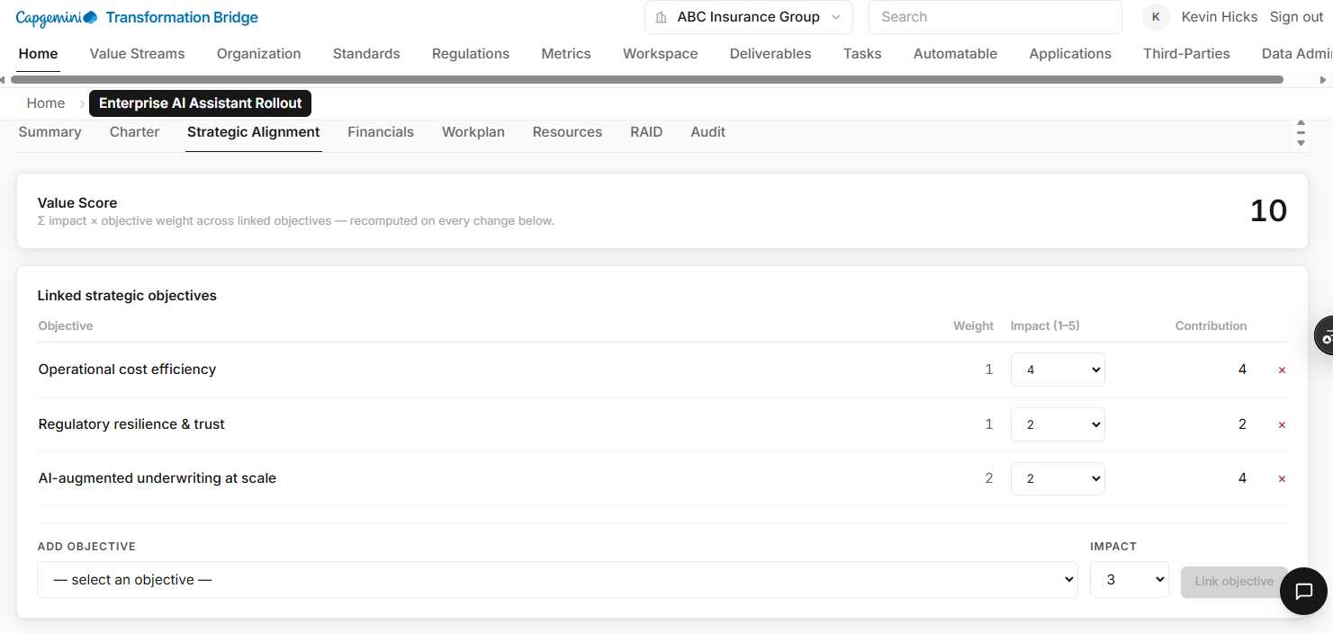
- Center align the numbers underneath contribution. More broadly, apply this pattern throughout the application except to large text fields underneath a header. Left align those.
- Bridge assistant should be context aware of the page you are on and provide relevant suggestions. Rename it Transformation Bridge and use the Capgemini Transformation Bridge logo from the top-left.
- Under Charter add project charter text. Use AI to create a Project Charter for the project (and for all projects we display)
- Under Financials Section re-focus the graph on Project Budget, Forecasted Budget, Forecast-to-date and actuals. Would also be more interesting if it had Change Impact on Budget and Timeline. Don’t need value score taking up so much space
- Move the cost card above benefits card
- Within the cards there is only Add a new benefit or cost or delete the item. Make it more clear you can click to edit (that the text is actually the hyperlink.
- 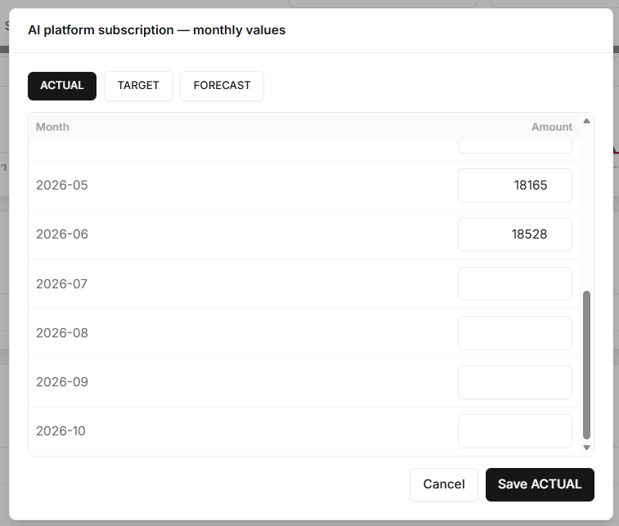
- This should be on one tab that shows actuals, target (relabel to budget) and forecast. Make sure audit log captures the change (who changed what when)
- 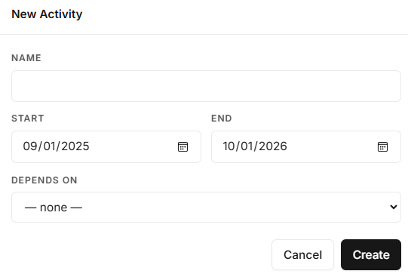
- The modal above should include “assigned to” and the depends on drop-down should be two drop downs the second depending on the fist. First drop-down would be dependency type. Values could be Team, Role, Person, Project (could be dependent on another project), Change Control Approval. The second drop down would be populated with actual values based on the type selected in the first drop down
- Stretch goal would be to enable a grid-based view that shows the actual plan (features, stories, tasks). We could even integrate with Jira to demonstrate there is bidirectional integration
- Populate resources tab with dummy data, but make it believable relative to the project scope. Add resource rate per hour, forecasted cost and actual cost and show the variance.
- 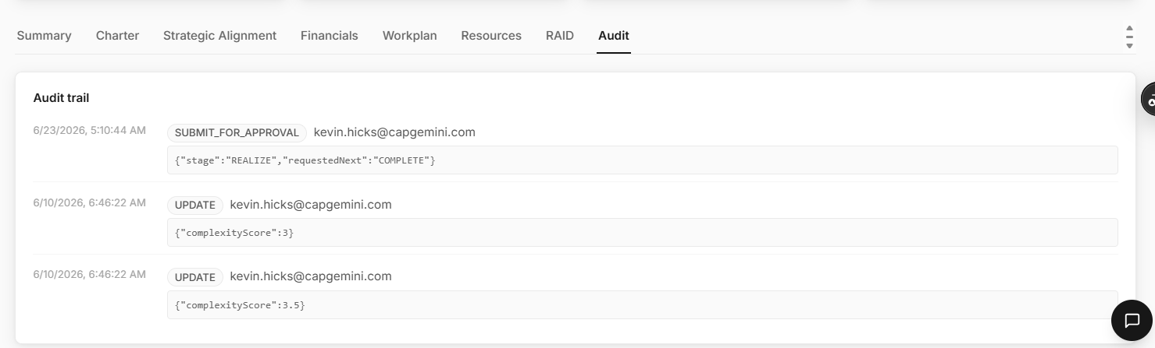
- Clean up audit log so it is more user friendly. This would be a filtered audit log narrowed for that project but here should be another audit log under admin
- 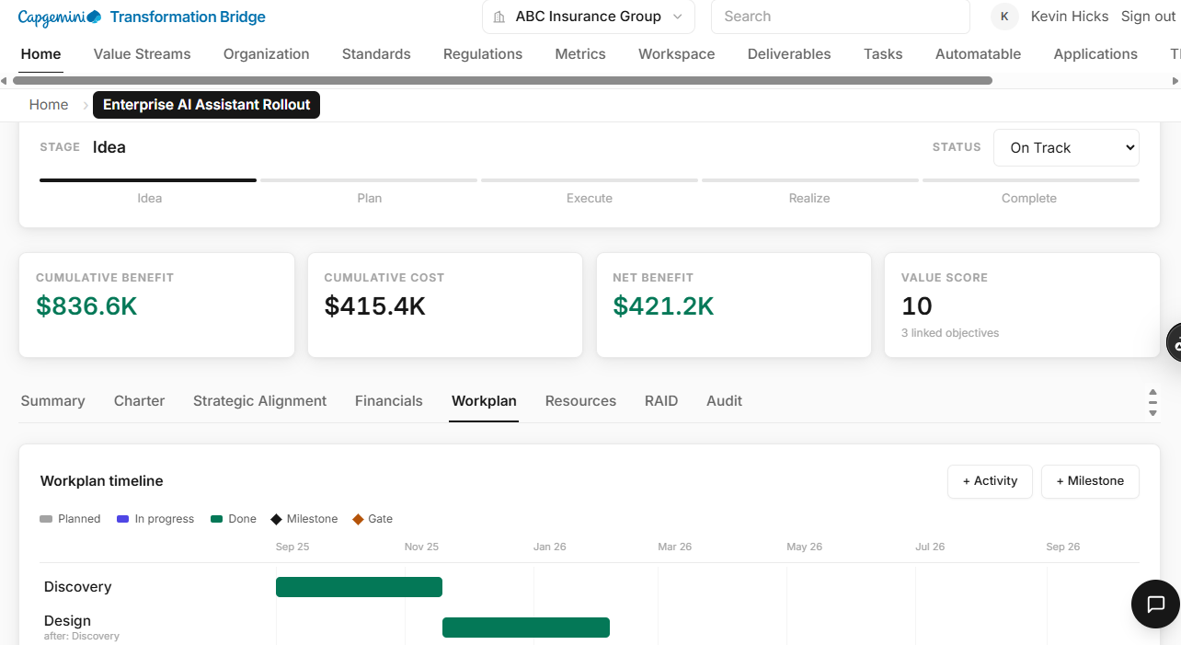
- Add a Change Log link to the right of Workplan. Should enable someone to see all of the changes. Who raised the change and when. Change Cost and Change Schedule Impact and a status if it is approved, pending and you should be able to create a new change request. I have many more ideas at this level but let’s just focus on getting the bulk of the scaffolding done
- 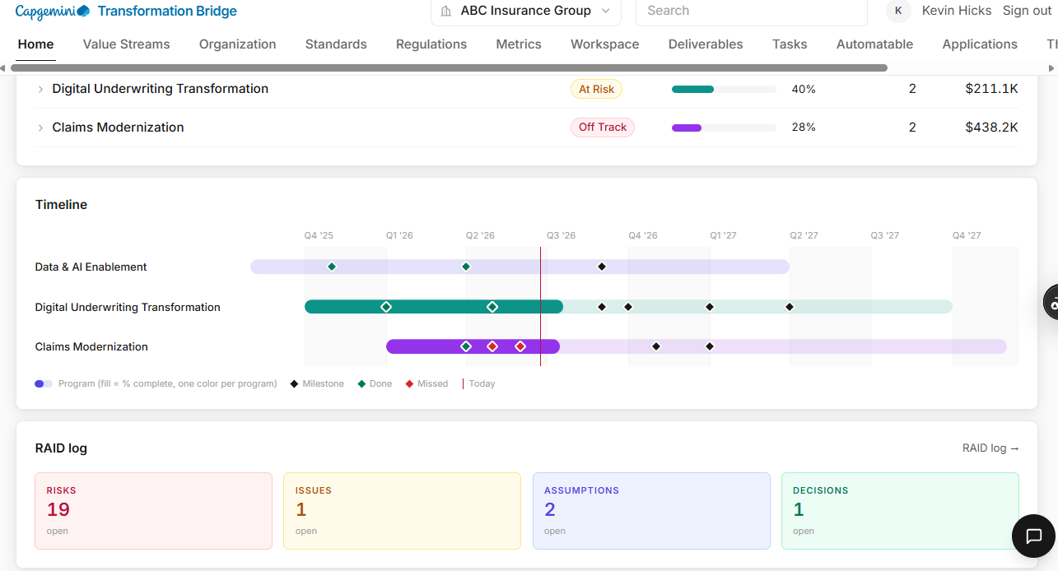
- This composite raid log re-label Portfolio RAID Log. Remove the small “open” text in the RAID log rectangles. I would also suggest showing the totals (implicitly that’s what you’re showing). Add “New” item clickable option. SO if there are 19 total says there 3 new ones. You often may just want to see the new ones.
- Address load times for big list screens, lazy loading or pre-fetching or something
- 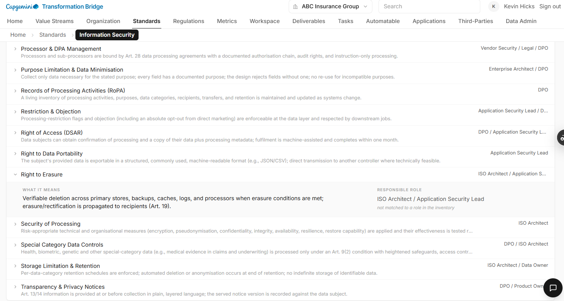
- On the standard selected above it says below the responsible role “not matched to a role in the inventory”. Remove that
- 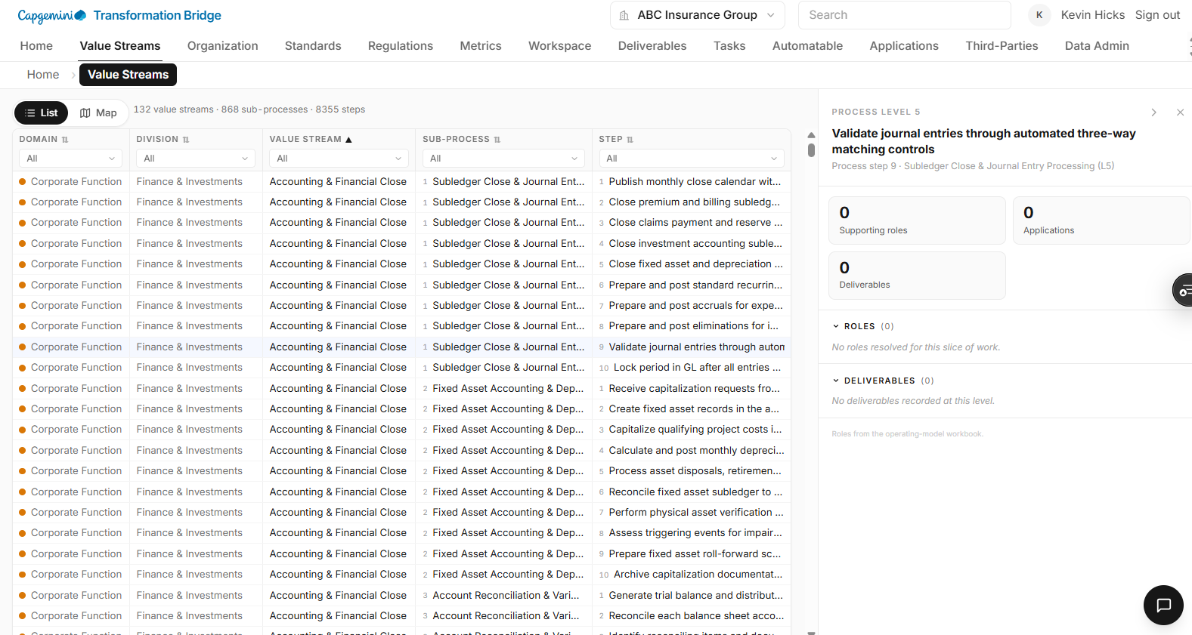
- Get the drill-down box on the right to populate. Add the “How” . and remove the big rectangles on the right. Save the space for the sections below.
- 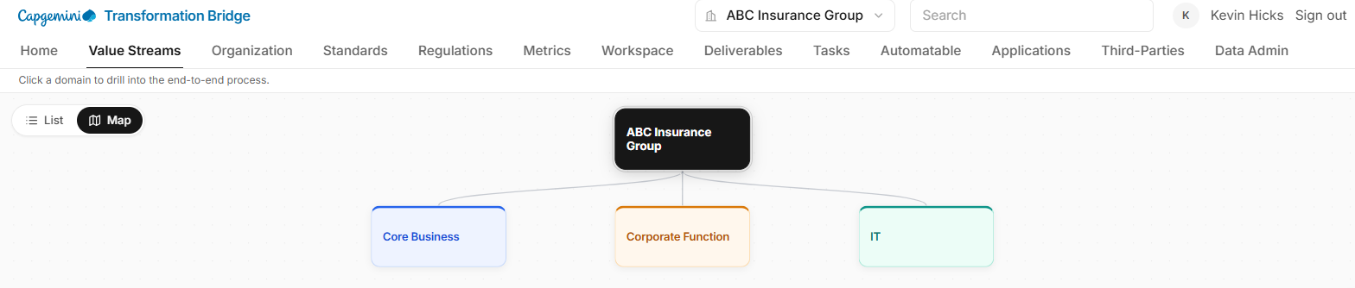
- Add and “s” to Corporate Function so it reads Corporate Functions. Change IT to read Technology
- 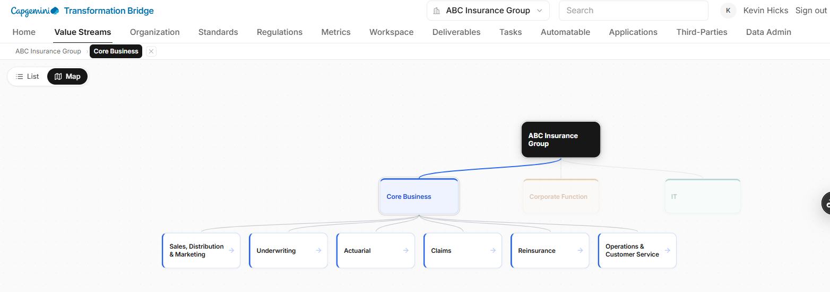
- As soon as I click the expansion moves the whole tree down relative to the top. Have it anchor at the top to maximize valuable screen real estate
- 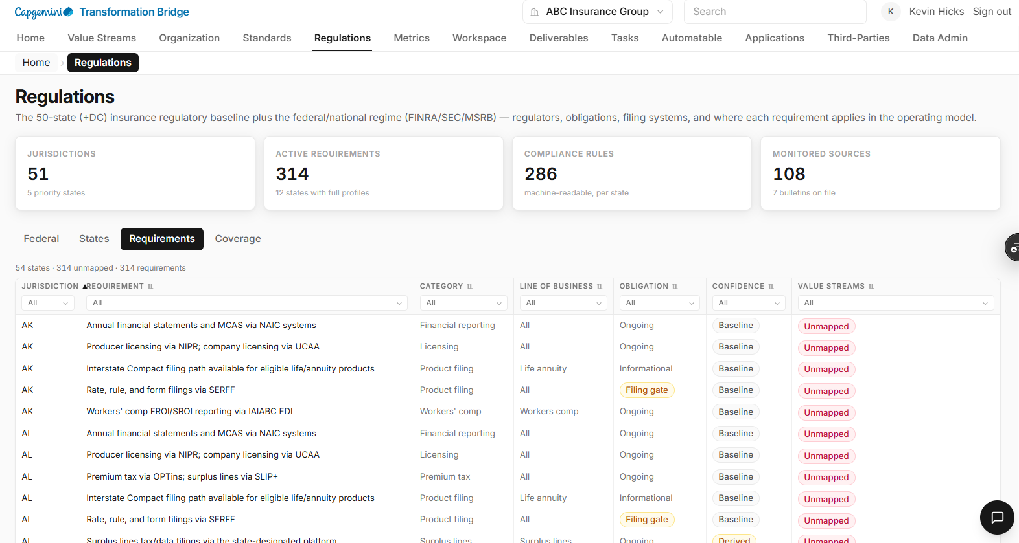
- Need to map some of these or get AI to attempt to
- GDPR should be under regulations, not standards.
- 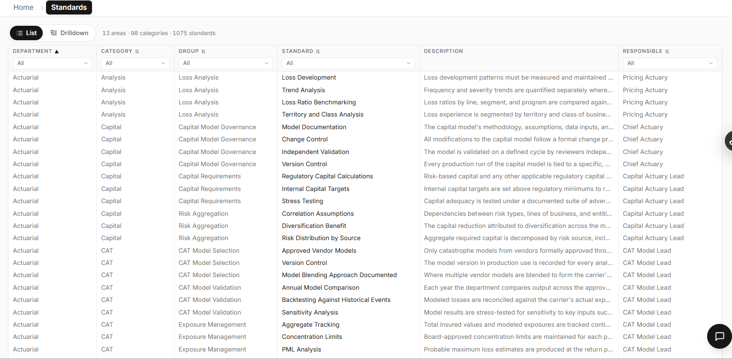
- Add search capability here like there is on the drilldown option
- Also re-assign where Chief Actuary or Chief anything is assigned low level tasks
- Remember we need to understand manager concept and also have the ability to add dotted lines reporting scenarios as this can impact capacity
- SOX should show up in regulations.
- GDPR should be in regulations
- 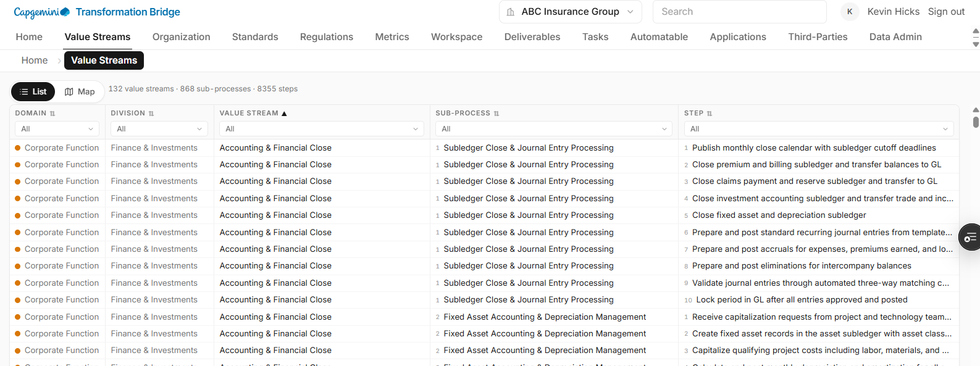
- Add Search above the list above
- Add the expandable / collapsible view back for Value Streams and let’s get Kelly’s input
- Relabel Sub-process and Step L4 Process, L5 Process, etc
- Bring ROLE back as a top-level menu item beside Org (to the right of it)
- 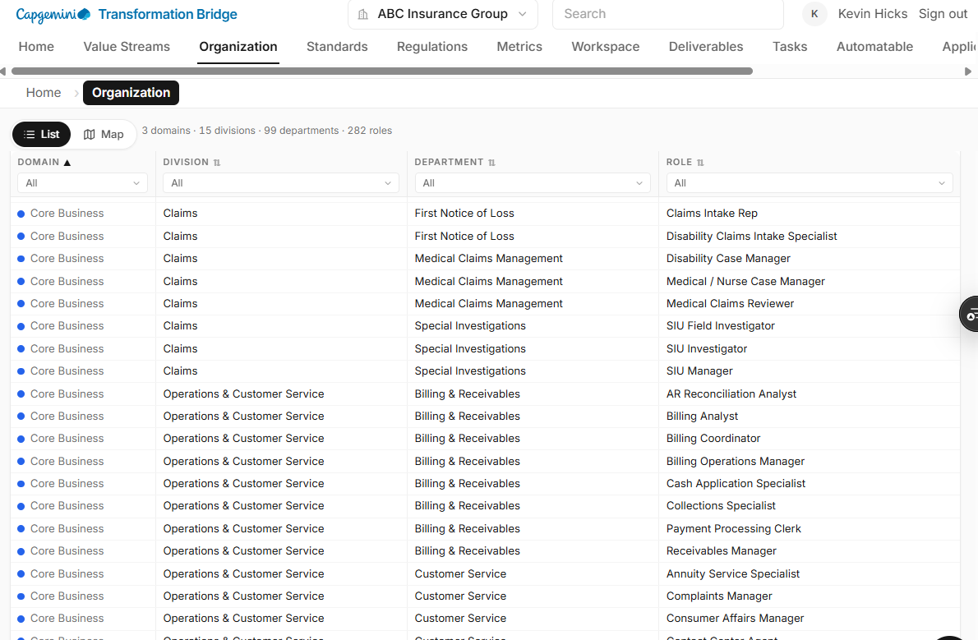
- Add Search immediately above the list. This search should be context aware
- Need to add Org level, Org unit, prior to the Role column above since roles may be aligned to different level.
- When you move role back as a top-level menu item the list screen would have Org level / Unit in one column with the role beside it. To the right of that you could list deliverables and maybe value streams they participate in. When you drill down effectively you would see the job description, tasks, deliverables, value streams in more detail
- 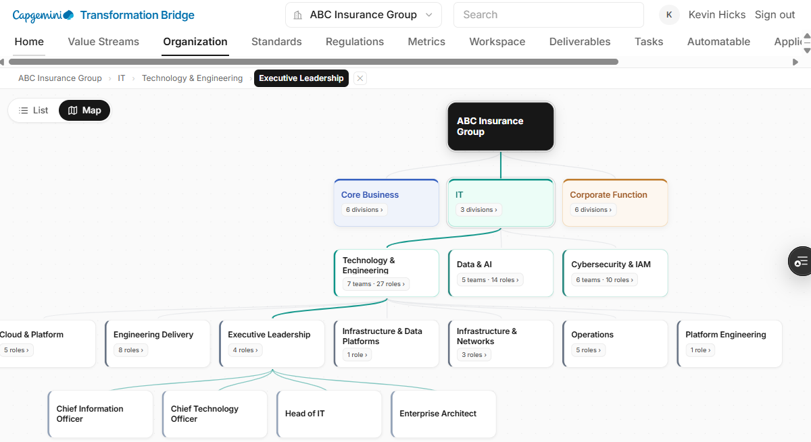
- I wouldn’t include Enterprise Architect in with CIO and CTO. I’d probably remove Head of IT too. See if the tasks should be ported over to the CIO or CTO
- Don’t forget to divide up the agent markdown files within standards section. Currently all of actuarial is in one file.
- Standards should break down to granular tasks that can be independently tested and provide evidence the granular standard is basically a rule or task that can be evidenced.
- 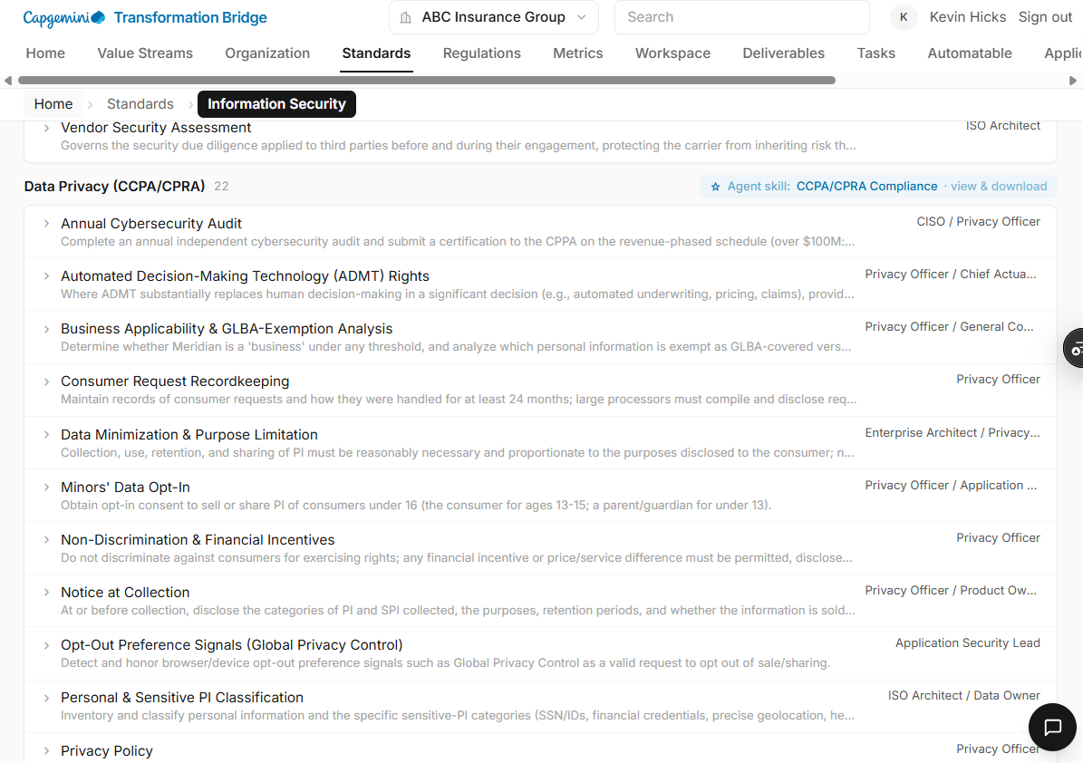
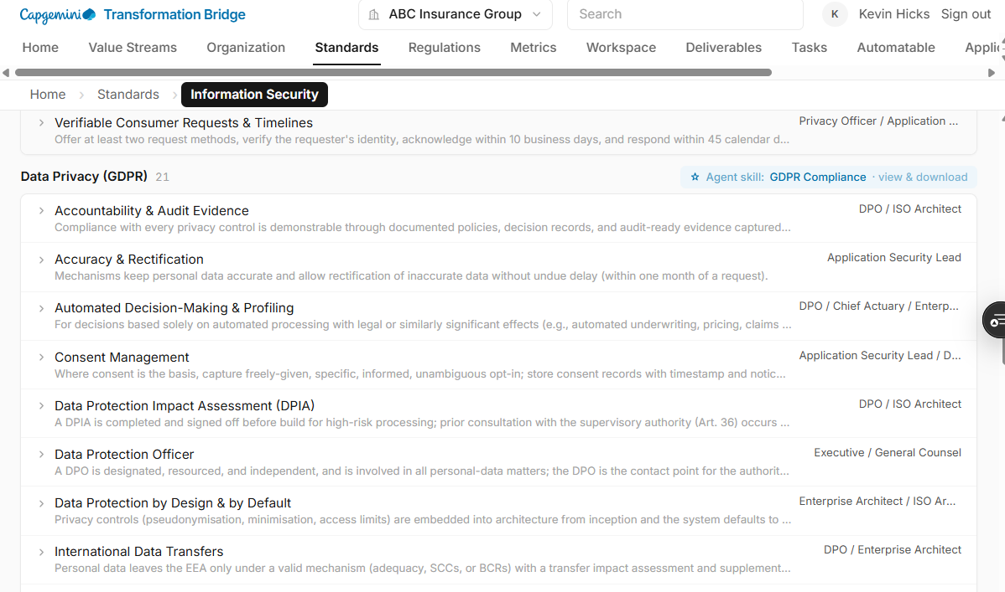
- CCPA, GDPR and NYDFS should be under regulations versus standards
- 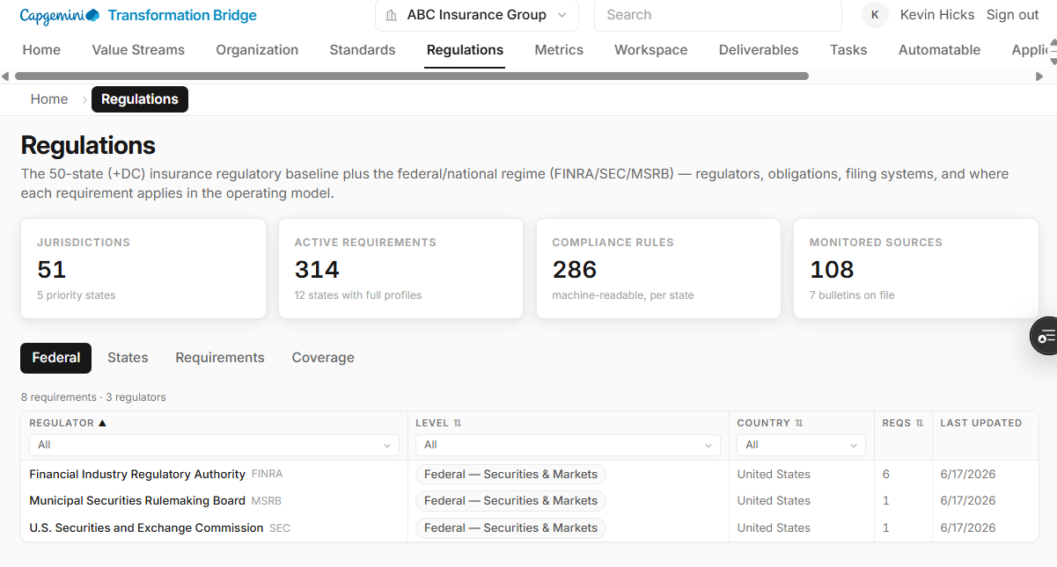
- Maybe add International to the left of Federal.
- Can we merge States and Requirements? Coverage needs to be either included with States in some way or down at the task level or maybe even move that to the Workspace section.
- 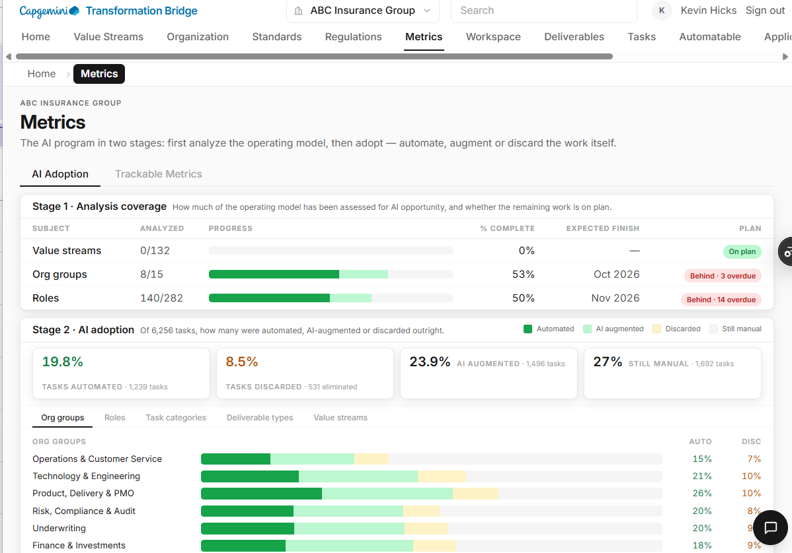
- Add Tasks to Stage 1
- Too much vertical space between Stage 1 Card and the top-level menu
- Stage 1 Card needs to be bigger. Call it Current State Analysis. Need to provide baseline inventory across for current state analysis including Orgs, Value Streams, Roles, Tasks, Deliverables and Systems of Record (debating on changing that to Applications). You will create knowledge bases for applications that aren’t systems of record. You could also call it Technology Catalog because is encompasses Applications, Tools, Services, SaaS, Infra, etc)
- 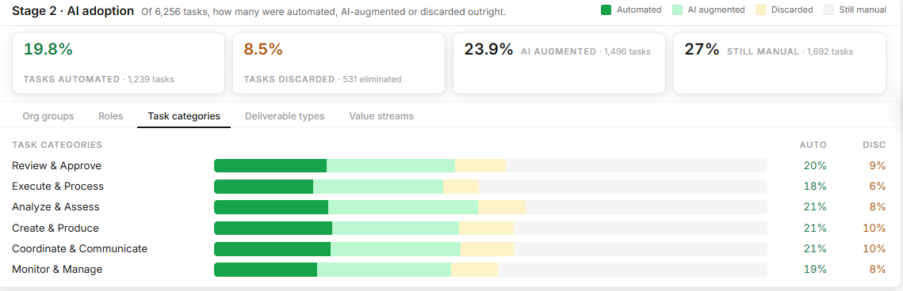
- All of this should be stage 1. What I would suspect in stage 2 is looking at rollout metrics, user and usage telemetry, # thumbs down, some type of feedback metrics to show what changes were made and how that improved quality and throughput. For now focus on stage one because it’s all about current state analysis, baselining and analyzing the opportunity so clients can come up with a multi-year plan.

